**EER Diagram**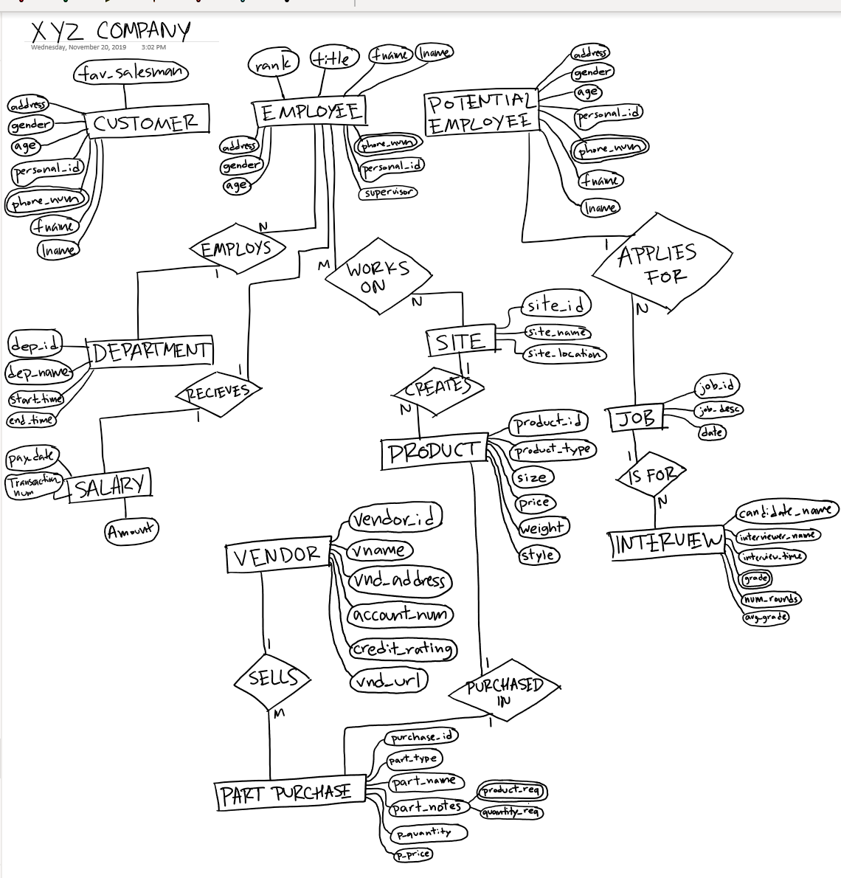

**Assumptions:**

**-employee has one direct supervisor**

**-employee can work in multiple environments though being assigned to one department**

**-transaction number for salary is distinct for each employee**

**-an individual can be customer, employee and potential employee but will be viewed as 3 separate entities**